A Rule-Constrained Large Language Model Pipeline for Patient-Friendly Interpretation of Vietnamese Blood Test Results
Trương Quang Đại¹ and Võ Hoàng Khang^{1,*}
¹ Vietnam-Korea Institute of Technology, HUTECH University, Ho Chi Minh City, Vietnam
{truongquangdaihutech@gmail.com, vh.khang@hutech.edu.vn}
* Corresponding author: Võ Hoàng Khang (vh.khang@hutech.edu.vn)
Abstract. Vietnamese patients increasingly ask general-purpose language models to explain laboratory reports, yet an unconstrained model can misstate results or falsely reassure. This study evaluates a rule-constrained pipeline in which deterministic rules assign every clinical label before invoking a language model; the model only paraphrases those labels, and a post-generation validator checks the output. On 150 synthetic complete blood count panels with known labels, an unconstrained Qwen2.5-3B model misstated at least one analyte direction in 91.3% of panels and falsely reassured in 32.0%. Prompt constraints reduced these rates to 12.7% and 8.0%; adding validation produced no unsafe output, with 64.0% of panels served by model text and 36.0% by fixed templates. The system runs on a CPU without a GPU. The contribution is an auditable architecture and a separately reported false-reassurance metric, not evidence of clinical benefit.
Keywords: health informatics, health literacy, large language models, laboratory results, output validation, patient safety.

1 Introduction
A patient leaving a Vietnamese laboratory receives a panel of values annotated with terms such as PDW, MCHC, and Monocyte, in units such as G/L, fL, and pg. The reference interval shows whether a value is out of range, but not what the analyte measures or whether the deviation matters. Health literacy remains limited in Vietnam, including among digitally connected adults [1–4], and patients who receive results without explanation often search online [5]. Increasingly, that search means pasting the report into a general-purpose language model.
Such models can fail in two ways. They can misstate facts: asked in Vietnamese what white blood cells are, the 3B model used here answered that they are lymphocytes and, unprompted, mentioned cancer. More consequentially, they can describe an abnormal panel as normal. This false reassurance is fluent and plausible, and it removes the reason to seek care, so we treat it as a distinct error class.
Three questions guide the study: (RQ1) How often does unconstrained generation misstate results or falsely reassure on panels with known labels? (RQ2) How much do rule-assigned labels and prompt constraints reduce these errors? (RQ3) Can a post-generation validator eliminate unsafe output, and at what cost in fallback and latency? The study is an internal evaluation on synthetic data, not a clinical trial.

2 Related Work and Contributions
Studies of language models for laboratory results mainly evaluate answer quality. He et al. [6] compared model and peer answers to patient questions, while Munoz-Zuluaga et al. [7] and Cadamuro et al. [8] reported incorrect or superficial answers and advised against diagnostic use. Similar assessments cover radiology reports [9] and scientific articles for patients [10]. Table 1 positions the present design against these studies; it is a selective comparison, not a systematic review.
Table 1. Comparison of related studies on language models explaining medical results.
Study | Data and design | Reported evidence | Comparison with this study
He et al. (2024) [6] | 53 patient questions from a health forum; LLMs vs. peer answers. | Relevance, accuracy, helpfulness, harm; GPT-4 best. | Here: rule-assigned labels and validated output.
Munoz-Zuluaga et al. (2023) [7] | 30 physician-written interpretation questions; GPT-4. | 46.7% correct, 23.3% partially correct, 30% incorrect. | Here: patient-facing; false reassurance measured.
Cadamuro et al. (2023) [8] | EFLM working-group assessment of ChatGPT on test results. | Superficial or incorrect answers; not for diagnosis. | Here: clinical judgement removed from the model.
Bozer and Pekçevik (2025) [9] | Radiology reports explained by several LLMs; expert rating. | Readability, understandability, communication. | Here: consistency with assigned labels.
This study | 150 synthetic CBC panels; 3 configurations; Qwen2.5-3B on CPU. | Six error classes, fallback rate, latency. | Auditable pipeline; no clinical validation.
Output control is a second line of work. Grammar-constrained decoding restricts generation to strings valid under a grammar [11], guided generation makes schema-constrained output efficient [12], and knowledge-constrained decoding prunes hallucinated tokens [13]. Structural validity does not ensure semantic correctness, so our validator checks content against labels computed independently of the model.
Unit heterogeneity is also known in laboratory data: 6–19% of tests could not be mapped accurately to LOINC in oncology data [14], harmonisation reduced 2,019 unit expressions to about 40 reference units [15], and automated LOINC mapping [16] and unit harmonisation [17] have been proposed. These works target data reuse; here, an unconverted unit caused a safety failure inside the rule layer.
The contribution is an architecture that separates clinical judgement from generation, a validator with template fallback, and an evaluation that reports false reassurance separately, together with a unit-normalisation failure observed on Vietnamese laboratory conventions. It does not propose a new language model or claim clinical benefit.

3 Rule-Constrained Pipeline
The design principle is that no clinical judgement is delegated to the language model. Fig. 1 shows the four layers: Layers 1, 2, and 4 are deterministic, and only Layer 3 uses the model.
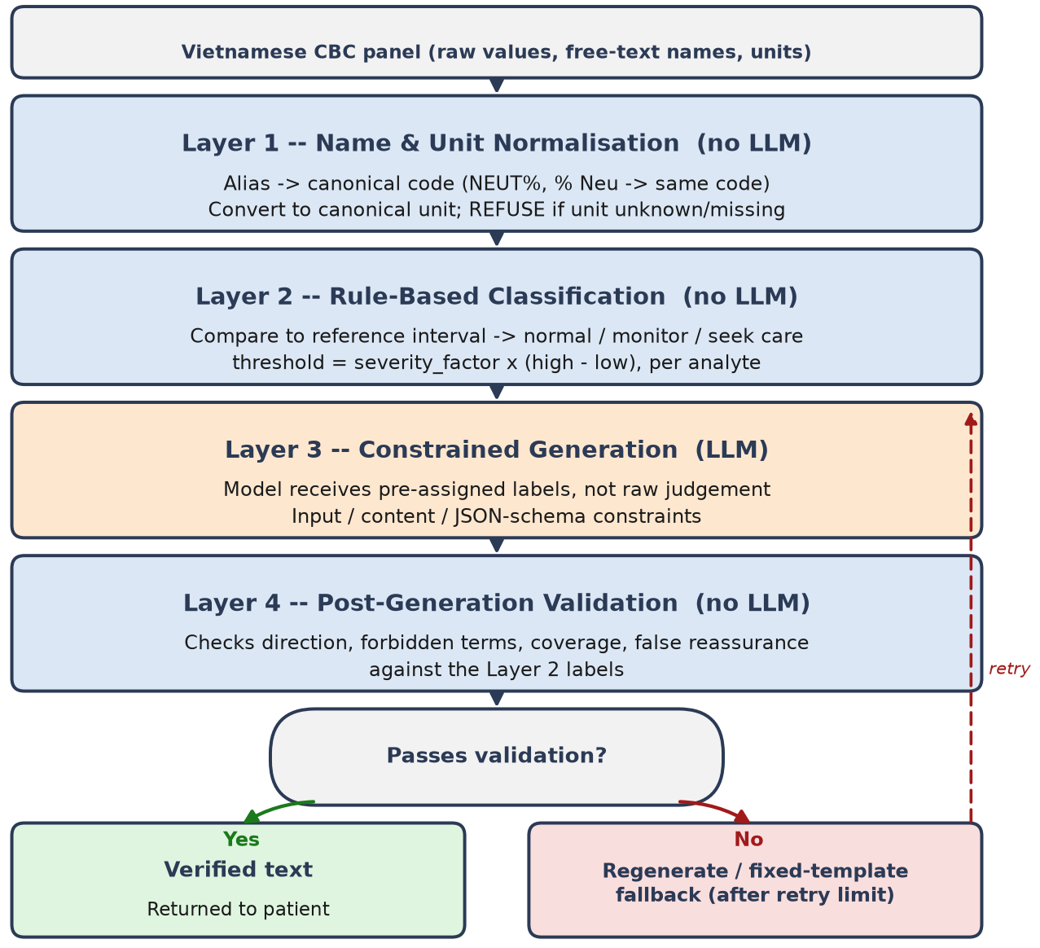
Fig. 1. Four-layer pipeline; clinical labels are fixed before generation and verified after it.

3.1 Normalisation and Rule-Based Classification
Layer 1 maps analyte aliases, such as WBC, SLBC, or the full Vietnamese name, to canonical codes; the % and # markers are kept as tokens so that NEUT% and NEUT# do not collapse into one key. Values are then converted to canonical units. Units matter: haemoglobin reported as 14 g/dL is normal, but compared directly with a 130–175 g/L interval it is classified as severe anaemia. Layer 1 therefore refuses an analyte whose unit is unrecognised or missing when units of different magnitude are possible, and reports it separately.
Layer 2 compares each value x_{j} with its reference interval [l_{j}, h_{j}] and assigns normal, monitor, or seek care. A value outside the interval is labelled monitor if its distance d_{j} to the nearest bound satisfies
d_{j} ≤ s_{j} (h_{j} − l_{j}), (1)
and seek care otherwise, where s_{j} is an analyte-specific severity factor between 0.15 and 0.50 for the 22 analytes. The factors were set heuristically, not from a critical-value list. The panel label is the most severe analyte label, so classification is exact by construction and cannot be altered by the model.

3.2 Constrained Generation and Validation
Layer 3 runs Qwen2.5-3B locally through Ollama, so laboratory data never leaves the institution. For each analyte, the prompt supplies the value, the interval, the pre-assigned direction and label, and a plain-language description. Three constraints apply: the model receives labels instead of deriving them; it must not name diseases, causes, medications, or treatments; and it must return a fixed JSON schema.
Layer 4 compares each generated item with the Layer 2 labels and detects six error classes: false reassurance in the closing statement, direction mismatch in the structured status field, contradictory wording in the prose, forbidden terms, fabricated analytes, and omitted analytes. Before pattern matching, text is lower-cased, Vietnamese diacritics are removed, and phrases naming the reference interval, such as “higher than normal”, are masked so that “normal” is not read as a status claim. A failing output is regenerated up to a limit and then replaced by a fixed template stating value, interval, and label, so the pipeline never returns unverified text.

4 Experimental Design

4.1 Synthetic Data and Configurations
The benchmark contains 150 synthetic complete blood count panels with 10–18 analytes each, divided equally into normal, monitor, and seek-care panels. Synthetic data provides known labels and a balanced design, and avoids handling patient records. Aliases and units are sampled at random to exercise Layer 1; values are rounded as laboratories print them, and panels whose rounded values leave the intended class are regenerated.
Three configurations are compared on the same panels. Baseline gives raw values and intervals to the model with no labels, constraints, or validation, approximating a patient pasting a report into a chatbot. Constrained uses Layers 1–3 without validation. Full uses all four layers.

4.2 Metrics
Safe output is the proportion of panels whose final output passes validation, including fallback templates; model-generated pass counts only panels passed by model text. Error metrics count panels with at least one instance of each of the six classes. Formatting errors, namely display names instead of canonical codes and unparseable JSON, are reported separately. Runtime was measured on an Intel Core i5-9400F with 24 GB RAM and no GPU. Each configuration was run once, and all results are descriptive.

5 Experimental Results
Table 2 reports the comparison. Every error metric decreases monotonically from baseline to constrained to full.
Table 2. Comparison of the three configurations on 150 synthetic panels (%).
Metric | Baseline | Constrained | Full
Safe output | 0.0 | 48.0 | 100.0
Model-generated pass | 0.0 | 48.0 | 64.0
False reassurance | 32.0 | 8.0 | 0.0
Direction mismatch | 91.3 | 12.7 | 0.0
Contradictory wording | 56.0 | 5.3 | 0.0
Forbidden terms | 79.3 | 15.3 | 0.0
Fabricated analytes | 32.0 | 10.0 | 0.0
Omitted analytes | 71.3 | 28.7 | 0.0
Mean time per panel (s) | 38.9 | 35.8 | 68.3
Unconstrained generation was unsafe. Baseline produced no acceptable output, misstated at least one direction in 91.3% of panels, and asserted that all results were normal on 32.0% of panels, roughly one patient in three. Pre-assigned labels and prompt constraints produced the largest drop, reducing direction mismatch to 12.7%, forbidden terms to 15.3%, contradictory wording to 5.3%, and false reassurance to 8.0%; nevertheless, 52.0% of constrained outputs still failed validation.
Full passed validation on all 150 panels. This figure requires qualification: 64.0% of panels were served by model text and 36.0% by fixed templates after regeneration failed. The guarantee is therefore a property of the pipeline, not evidence that a 3B model writes reliably, although regeneration raised the model-generated pass rate from 48.0% to 64.0%.
In baseline, 97.3% of outputs used display names instead of canonical codes and 2.0% were unparseable; both fell to zero under the schema constraint. Full required 1.97 generation attempts on average and 68.3 s per panel, about twice the baseline latency.

6 Discussion and Application Prospects

6.1 Implications for Health Informatics
The results support a division of labour rather than better prompting: comparison against a reference interval is left to rules, and paraphrasing to the model. The two components can then improve independently; replacing heuristic thresholds with a laboratory's critical-value list changes only the labels, and a larger model would raise the model-generated pass rate without changing the guarantee supplied by Layer 4.
False reassurance deserves separate reporting. It may score well on readability because it is simple and calming, yet it was neither rare nor removed by instruction and reached zero only with mechanical verification. A prompt-level prohibition should not be taken as evidence of its absence.
Unit heterogeneity is a safety problem, not only a data-reuse problem. The g/dL-versus-g/L failure occurred in the deterministic layer with complete internal consistency, and no downstream check could detect it; standards such as LOINC and HL7 FHIR are therefore preconditions for rule-based clinical logic in Vietnamese laboratory reporting. A CPU runtime of 68.3 s per panel is acceptable for a once-per-report task and avoids GPU cost for provincial hospitals; for the 36.0% fallback panels, output is no better than the report but never misleading.

6.2 Study Limitations
No medical professional reviewed the outputs, so they are shown to be consistent with the assigned labels, not clinically appropriate or comprehensible. The severity factors are heuristic and are not clinical recommendations. Panels are synthetic and lack the noise, missing fields, and format variation of real reports, and Layer 4 matches surface patterns that indirect phrasing can evade.
Only structured complete blood count panels are supported; one-sided intervals, qualitative results, and sex- or age-specific intervals are not handled, and results come from one 3B model. Expert review, validated critical-value thresholds, broader test panels, and evaluation on real reports from multiple laboratories remain future work.

7 Conclusion
This study presents a pipeline in which rules fix every clinical label before a language model paraphrases it and a validator checks the result. On 150 synthetic panels, false reassurance fell from 32.0% under unconstrained generation to 8.0% with prompt constraints and to zero with validation, with 64.0% of panels served by model text and 36.0% by templates. The contribution is an auditable architecture and a separately reported false-reassurance metric; clinical validation is required before any patient-facing use.

References
- Tran, M.T., Lai, H.T., Hoang, H.T., et al.: Health literacy among older adults: a descriptive cross-sectional analysis in Vietnam. Journal of Health Literacy 10(2), 91–100 (2025). https://doi.org/10.22038/jhl.2025.82477.1632
- Hoa, H.V., Giang, H.T., Vu, P.T., Tuyen, D.V., Khue, P.M.: Factors associated with health literacy among the elderly people in Vietnam. BioMed Research International 2020, 3490635 (2020). https://doi.org/10.1155/2020/3490635
- Dinh, T.T.H., Bonner, A.: Psychometric properties of the health literacy questionnaire tested in Vietnamese adults with chronic diseases. BMC Public Health 25, 44 (2025). https://doi.org/10.1186/s12889-024-21156-7
- Nguyen, B.N., Ngo, T.T., et al.: Health and eHealth literacy in Vietnam: evidence from a national survey. Patient Education and Counseling 148, 109583 (2026). https://doi.org/10.1016/j.pec.2026.109583
- Giardina, T.D., Baldwin, J., Nystrom, D.T., Sittig, D.F., Singh, H.: Patient perceptions of receiving test results via online portals: a mixed-methods study. Journal of the American Medical Informatics Association 25(4), 440–446 (2018)
- He, Z., Bhasuran, B., Jin, Q., et al.: Quality of answers of generative large language models versus peer users for interpreting laboratory test results for lay patients: evaluation study. Journal of Medical Internet Research 26, e56655 (2024). https://doi.org/10.2196/56655
- Munoz-Zuluaga, C., Zhao, Z., Wang, F., Greenblatt, M.B., Yang, H.S.: Assessing the accuracy and clinical utility of ChatGPT in laboratory medicine. Clinical Chemistry 69(8), 939–940 (2023)
- Cadamuro, J., Cabitza, F., Debeljak, Z., et al.: Potentials and pitfalls of ChatGPT and natural-language artificial intelligence models for the understanding of laboratory medicine test results. Clinical Chemistry and Laboratory Medicine 61(7), 1158–1166 (2023)
- Bozer, A., Pekçevik, Y.: Comparative evaluation of large language models in explaining radiology reports: expert assessment of readability, understandability, and communication features. Insights into Imaging 16, 232 (2025). https://doi.org/10.1186/s13244-025-02121-3
- Kianian, R., Sun, D., Rojas-Carabali, W., Agrawal, R., Tsui, E.: Large language models may help patients understand peer-reviewed scientific articles about ophthalmology: development and usability study. Journal of Medical Internet Research 26, e59843 (2024). https://doi.org/10.2196/59843
- Geng, S., Josifoski, M., Peyrard, M., West, R.: Grammar-constrained decoding for structured NLP tasks without finetuning. In: Proceedings of the 2023 Conference on Empirical Methods in Natural Language Processing (2023)
- Willard, B.T., Louf, R.: Efficient guided generation for large language models. arXiv:2307.09702 (2023)
- Choi, S., Fang, T., Wang, Z., Song, Y.: KCTS: knowledge-constrained tree search decoding with token-level hallucination detection. In: Proceedings of the 2023 Conference on Empirical Methods in Natural Language Processing (2023). https://doi.org/10.18653/v1/2023.emnlp-main.867
- Naliyatthaliyazchayil, P., Stenerson, T.: Harmonizing Logical Observation Identifiers Names and Codes (LOINC) codes and units in real-world oncology data: method development and evaluation. JMIR Medical Informatics 14, e81254 (2026). https://doi.org/10.2196/81254
- Zayed, A.M., Sarikakis, I., Delvaux, N.: Automated standardization and harmonization of laboratory units in large-scale clinical data using open-source R functions. International Journal of Medical Informatics 205, 106131 (2025). https://doi.org/10.1016/j.ijmedinf.2025.106131
- Parr, S.K., Shotwell, M.S., Jeffery, A.D., Lasko, T.A., Matheny, M.E.: Automated mapping of laboratory tests to LOINC codes using noisy labels in a national electronic health record system database. Journal of the American Medical Informatics Association 25(10), 1292–1300 (2018). https://doi.org/10.1093/jamia/ocy110
- de la Torre, J.: Scalable unit harmonization in medical informatics via Bayesian-optimized retrieval and transformer-based re-ranking. International Journal of Medical Informatics 206, 106180 (2026). https://doi.org/10.1016/j.ijmedinf.2025.106180

